**WEEK -01**

**STEP 1:** Install the Microsoft Power BI desktop app for the windows.

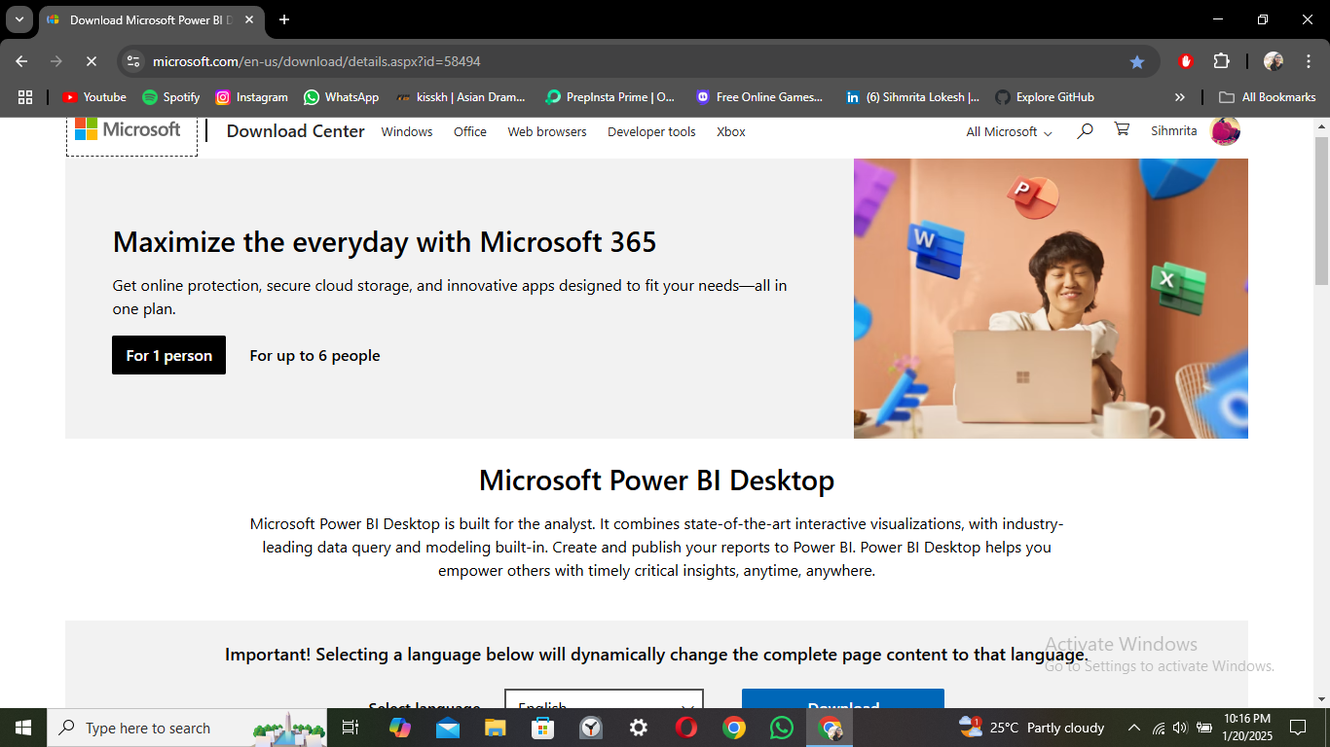

**STEP 2:** Open the front page of the power BI app. Click on the blank report to start a new project.

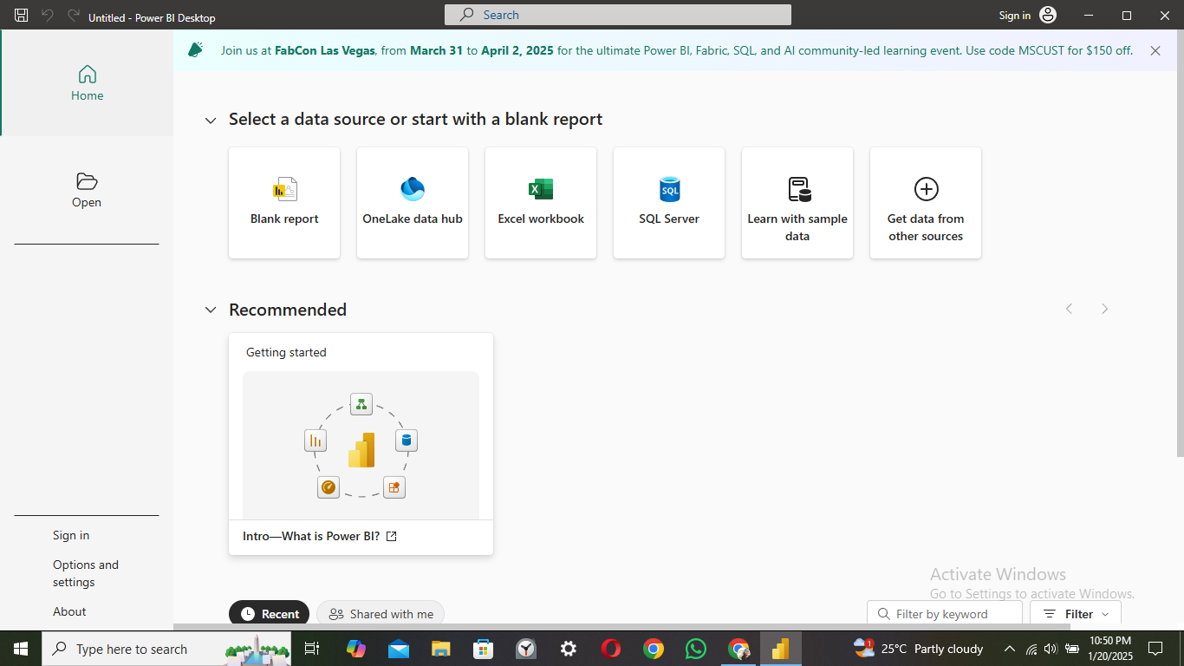

**STEP 3:** Click on the Get data bin to load the required dataset file that is pre-installed in the system files with extensions like .csv, .exe, etc.,

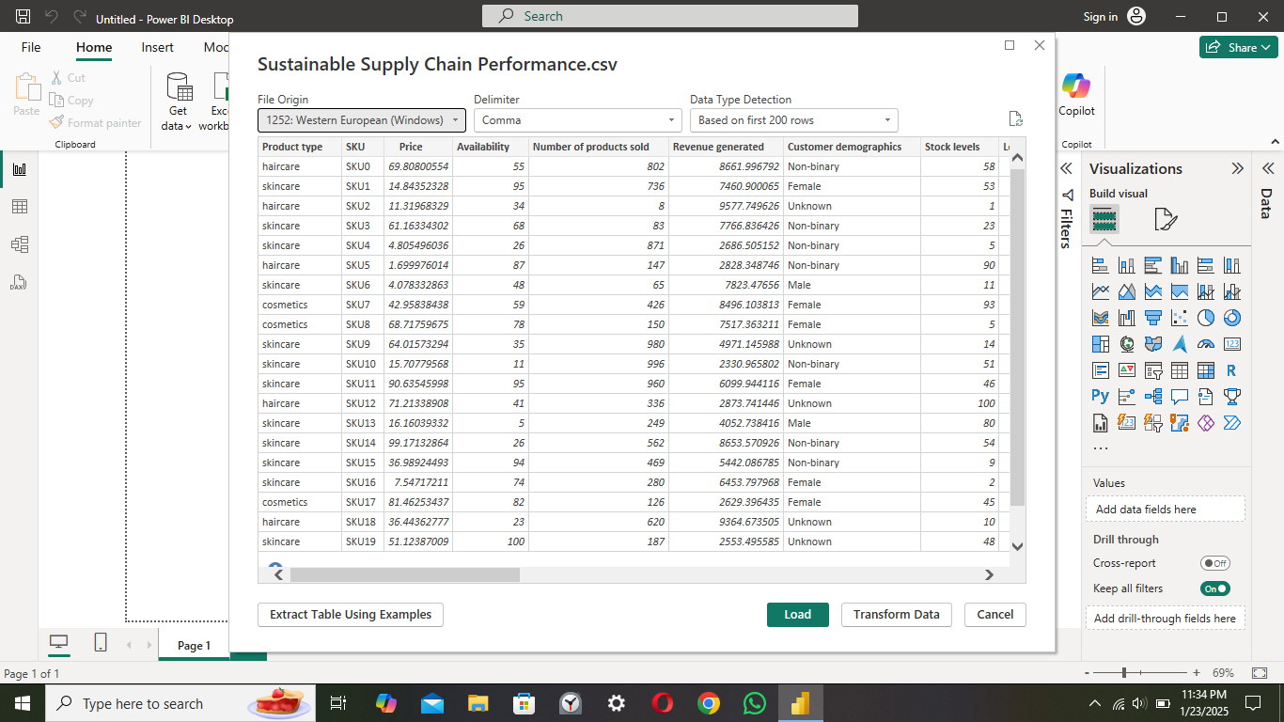

**STEP 4:** Dataset is loaded successfully and to view the dataset click on the table in the left side of the page.

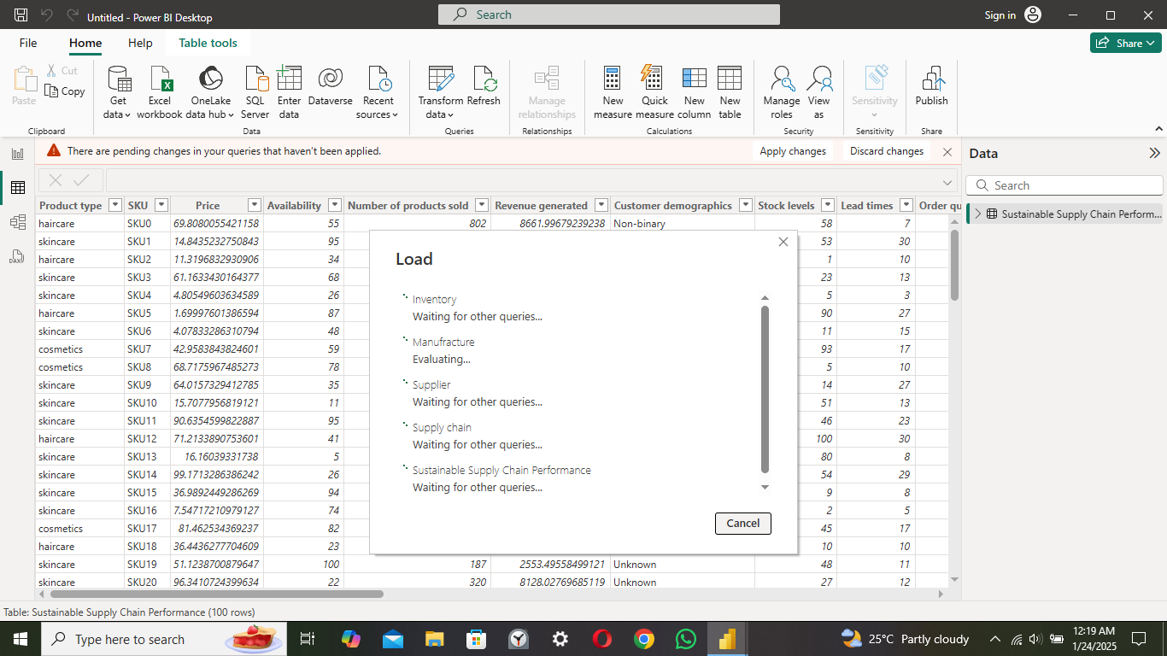

**STEP 5:** Click on the Transform data option to modify the loaded dataset.

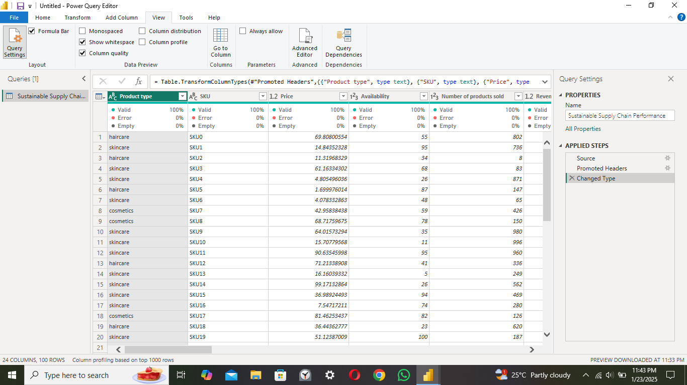

**STEP 6:** Create a duplicate file for modifications and for removal of unrelated columns.

Inspect inventory data , filter rows , remove unwanted columns and update data formats .

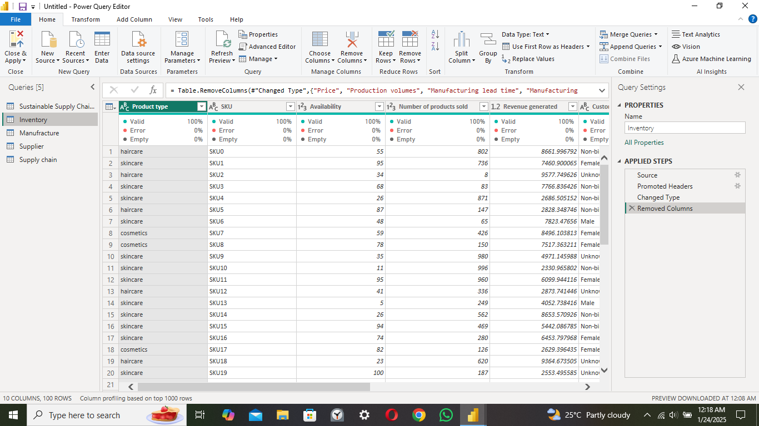

Validate supplier data , remove irrelevant columns and update data formats

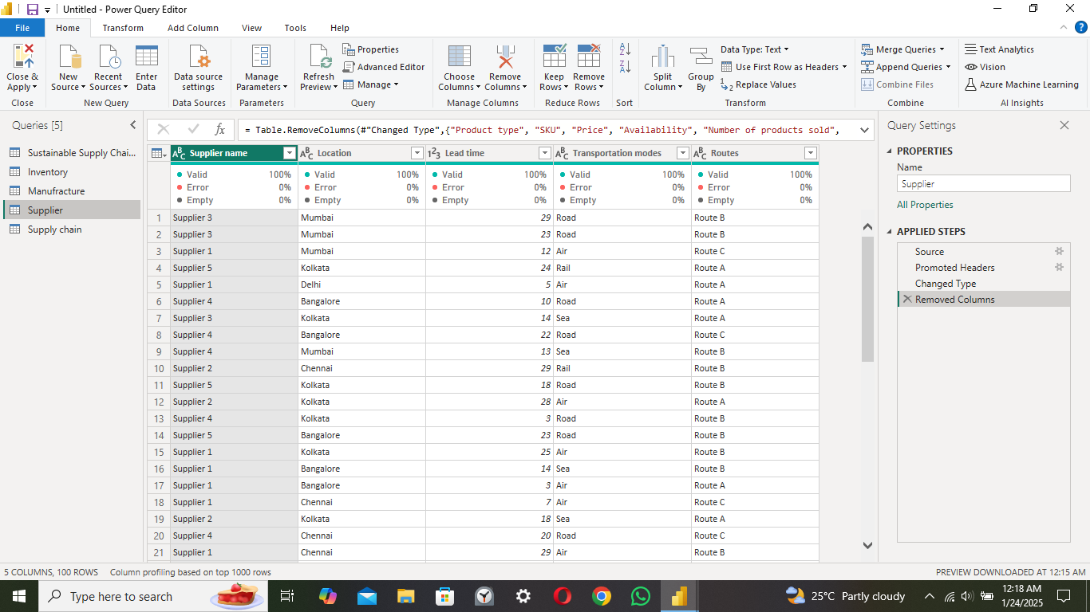

**STEP 7 :**

Check production data , apply transformations , filter rows and summarize key metrics.

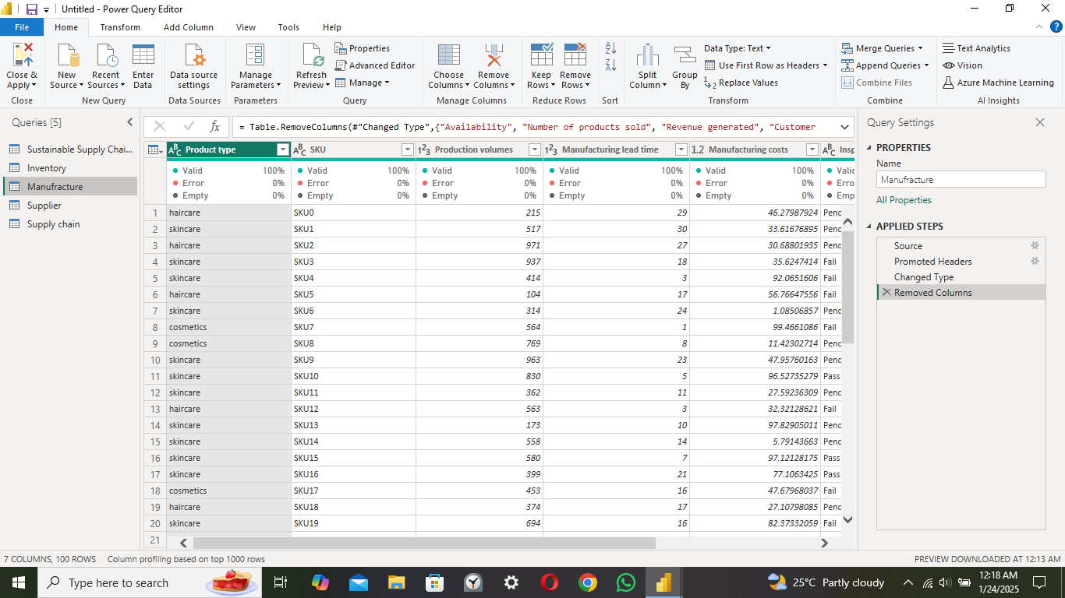

**STEP 8:**

Remove unnecessary columns , validate data , clean and prepare for visualization.

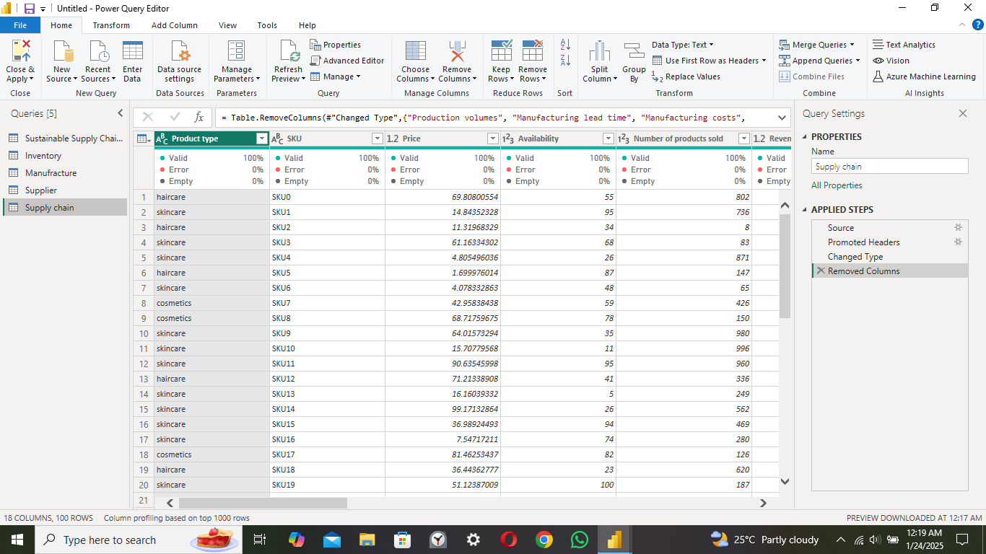

**STEP 9:** Click the close and apply option to save the modifications.



This image shows the steps that we applied previously. Can be viewed in the right side of the page while doing the modifications.

**STEP 10:** The dataset is now ready for further processing of the project.

